CHAPTER ONE
INTRODUCTION
  - Background
Thorny-headed worms, or Acanthocephala, are a phylum of obligatory endoparasites of vertebrates that alternately employ arthropods to finish their life cycle (Gazi et al., 2016). This phylum is currently classified into four classes: Archiacanthocephala, Eoacanthocephala, Palaeacanthocephala, and Polyacanthocephala. (Muhammad et al., 2019, Amin, 2013; Gazi et al., 2016). The classification of Acanthocephala is still up for question, nevertheless, with some investigations indicating that some orders are paraphyly (Gao et al., 2022).
Acanthocephala consists of over 1200 species based on the latest available data from a decade ago. (Amin, 2013 & Perrot-Minnot et al., 2023). Acanthocephala can be detected in almost all classes of vertebrates, and historical evidence suggests they may have frequently infected humans (Haustein et al., 2010).
Rodents can act as reservoirs of various parasites, which may include both external and internal parasites. However, rodents are widely distributed and have a close relationship with humans, and this is crucial from the viewpoint of public health (Seifollahi et al., 2016). Rodent-borne disease can be transmitted to humans either by direct route (such as biting them, consuming food products contaminated with rodent feces) or indirect route by means of ectoparasite arthropod vectors (Meerburg et al., 2009).

  - Problem Statement
Acanthocephalans is a phylum of parasitic pseudocoelomates that infect a variety of invertebrate hosts and have the potential to infect humans zoonoticly (Mathison et al., 2021). Studies reporting the infection of humans with Acanthocephalans are scarce to be found in literature. However, since ancient times, humans have been linked to acanthocephalans (W. Lotfy, 2020). In spite of their medical and economic importance, Acanthocephalans have been identified as good indicators of monitoring environmental contamination (W. M. Lotfy, 2020). Records of human Acanthocephala infection is scarce, though there are different cases of different species that have been reported (Roberts and Janovy, 2005; Berenji et al., 2007).

  - Justification
There is the need to understand the prevalence and distribution of these parasites to anticipation outbreak
Brown and black rats are known to have originated from Asia and are present all over the world to date with humans. These rodents have found their way to introduce into new geographical areas, new pathogenic microorganisms (Tanja M.S et al., 2019). Rodent-borne diseases are neglected diseases that mostly affect people living in developing and low-income countries (World Health Organization, 2012). In the area of public health, rodents are known to be key reservoirs for several zoonotic helminths, whereas a great number of species of rodents can carry zoonotic parasites (Dini et al., 2024).
Rodents often serve as reservoirs which are crucial in the transmission and spread of at least 60 zoonotic illnesses in a variety of ways(Dahmana et al., 2020). These worms have enabled research by serving as models for investigating parasitic biology, evolutionary ecology, and ecotoxicology (Rahdar et al., 2016; Zarei et al., 2012; Perrot - Minnot et al., 2023). These worms have also been used as effective to monitor environmental pollution due to their ability to bioaccumulate contaminants (Perrot-Minnot et al., 2023).
  - General objective
To genetically characterize Acanthocephala species isolated from rodents using mitochondrial markers.

CHAPTER TWO
2.0. Literature review
2.1 Morphology of Acanthocephala in Rodents
Recent studies of Acanthocephala morphology in rodents have contributed to expanding our knowledge on Acanthocephala species (Gomes et al., 2020). New morphological observation were reported for Macracanthorhynchus hirudinaceus originating from Ukrainian wild boars, comprising detailed description of the proboscis structures and hook composition (Heckmann et al., 2021). The proboscis receptacle is a double-walled with the outer layer composed of muscle fibers, typically in a spiral form (Beatriz et al., 2017).
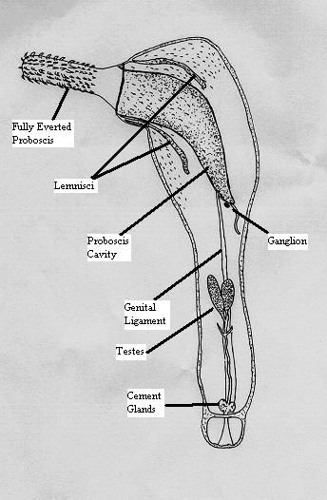
Figure 1: Morphology of Acanthocephala in rodents
Source: https://pin.it/3RwpNbmAI

2.2 Lifecycle of Acanthocephala in Rodents
All acanthocephalans use vertebrates as definitive hosts and arthropods as intermediate hosts in their basic life cycle (McDonough et al., 2023, Kennedy, 2006). The three most prevalent species linked to human illness, M. hirudinaceus, M. ingens, and M. moniliformis, use rodents, racoons, and pigs as their major definitive hosts, however other carnivores may also serve as definitive hosts (Mathison et al., 2016).
The final host excretes fully developed eggs that contain an infectious first-stage larva (acanthor). An arthropod intermediate host consumes the eggs. While arthropods don’t seem to be highly specific to their hosts, some of the main categories that typically act as vectors are millipedes for M. ingens, scarabaeoid beetles for M. hirudinaceus, and different cockroaches and beetles for M. moniliformis (García-Varela et al., 2002). The parasite undergoes several phases within the arthropod host, including acanthor, acanthella, and the cystacanth stage is the infectious stage for the definitive host (Mathison et al., 2021).
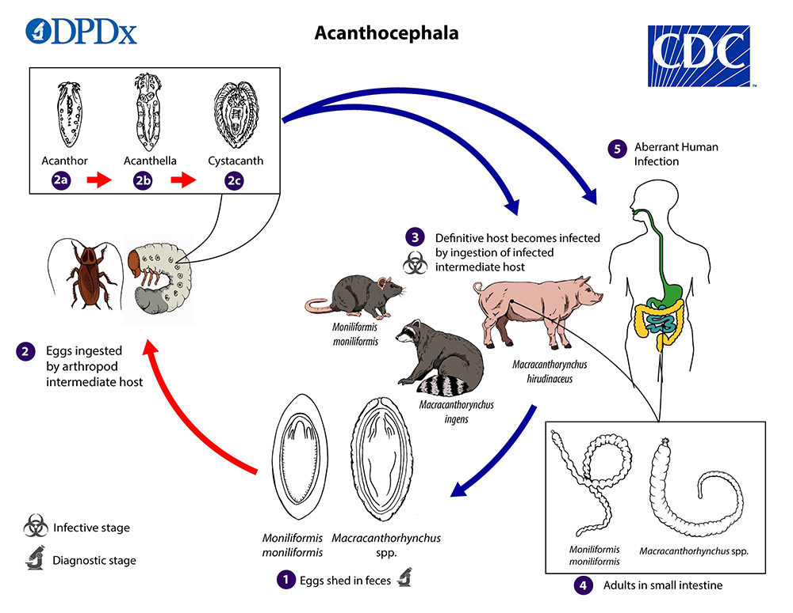
Figure 2: Life cycle of Acanthocephala in Rodents.
Source׃ https://www.cdc.gov/dpdx/acanthocephaliasis/index.html

2.3 Transmission of Acanthocephala in Rodents
Acanthocephalans are helminths transmitted through trophic interactions, typically having a life cycle that includes two consecutive hosts: an arthropod acting as an intermediate host and its vertebrate predator, where the parasite reproduces sexually within the digestive system. Their ability to modify the antipredator behavior of their intermediate hosts, either established or assumed, is examined, including shifts in microhabitat preference and defensive or escape responses triggered by cues (Fayord et al., 2020). Alterations that seem to enhance parasite transmission appear limited to the parasite's inactive developmental stage in the definitive host – cystacanth – whereas the younger non-infective stage – acanthella – either induces the opposite changes or none at all (Dianne, L et al., 2011, Fayard et al., 2020).
In Acanthocephalans, the typical transmission cycle involves a vertebrate as the definitive host and an arthropod as the intermediate host (Kennedy, 2006). Developed eggs are released from the final host into the surroundings, where they are ingested by an intermediate host. The parasite emerges from the egg and proceeds through numerous developmental stages after being devoured by the intermediate host, or larval stage. The final stage of development (Cystacanth) in the intermediate host can be infectious to the final hosts (Near, 2002).

2.4 Infections of Rodents Origin
There have been reports of at least nine acanthocephalan species infecting humans; the most prevalent ones are Macracanthorhynchus hirudinaceus and Moniliformis Fayard (W. M. Lotfy, 2020). The bulk of human infections are caused by intestinal parasites of marine species, known as Acanthocephalans, and terrestrial mammals, known as Moniliformis. (Mathison et al., 2016). Human infections typically occur in areas where M. hirudinaceus is highly prevalent in pigs and where people frequently eat raw or underroasted insects for culinary or therapeutic purposes. The parasite uses its proboscis to adhere securely to the intestinal mucosa after intake. This could result to the development of granuloma and inflammation.(W. Lotfy, 2020)
The Moniliformis under roasted is a parasite found globally, that mostly affects voles, rats and mice, and cockroaches and beetles being their intermediate hosts and it is found in the intestine. Many larval stages of the parasite, including acanthor, acanthella, and the infectious cystacanth, develop inside the intermediate host. (Tošić et al., 2024). The presence of M. moniliformis influences cockroaches' capacity to effectively avoid predators, which is advantageous to the parasite since it increases the likelihood that the rodents’s final host will consume the cockroach, enabling the parasite to complete its life cycle. Ingesting insects carrying the cystacanth larvae infects the definitive hosts, which include humans (Tošić et al., 2024). There have been very few human cases of Acanthocephala infections, and Moniliformis rodents’ is the most prevalent species worldwide. We describe a case of M. moniliformis infection in a 2-year-old Iranian child that was discovered in her feces. The patient experienced vomiting, diarrhea, facial edema, and stomach pain. The patient had a propensity of eating dirt, and her mother claims that she once found a cockroach in her mouth. (Berenji et al., 2007).

2.5 Prevention and Control of Acanthocephala infections
The search for alternative solutions for managing acanthocephalans are on the rise, driven by the fact that elimination requires culling of the fish once the parasites become established in fish ponds (Jeronimo et al., 2021). In light of the significant number of acanthocephalan cases, often linked to mortality in Brazil, and the widespread use of chemotherapeutic agents, it is imperative to implement preventive strategies and emergency response plans to manage the disease effectively (Ramos et al., 2020).
Among disease prevention strategies in aquaculture, vaccines are highly efficient, however, there are no available vaccines for acanthocephaliasis, highlighting a gap in current research. In aquaculture, dietary additives with anti – helminthic and immunostimulant are commonly used to prevent disease. These additives may reduce the parasites’ ability to reproduce by directly affecting them (Seixas, 2020). The most efficient way to prevent this is to avoid eating the implicated species raw (W. M. Lotfy, 2020).

` CHAPTER 3
3.1 STUDY AREA
The samples were inherited from our seniors who took them in the Northen Region (Tamale) from three different specific markets namely; Central market, Aboabo and Lameshegu market.
3.2 MATERIALS
Below are some of the materials that were used for the work.
0.5 µl PCR tubes, Tris-borate-EDTA (TBE), Agarose powder, Ethidium Bromide, Microwave, Electronic scale, Micropipette, Petri dish, Eppendorf tubes, Flame, 70% Ethanol, thermal cycler and many more
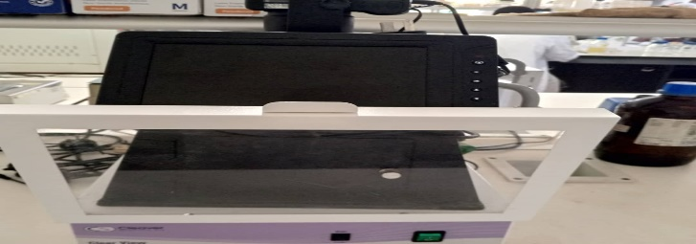
Figure 2: UV Transilluminator

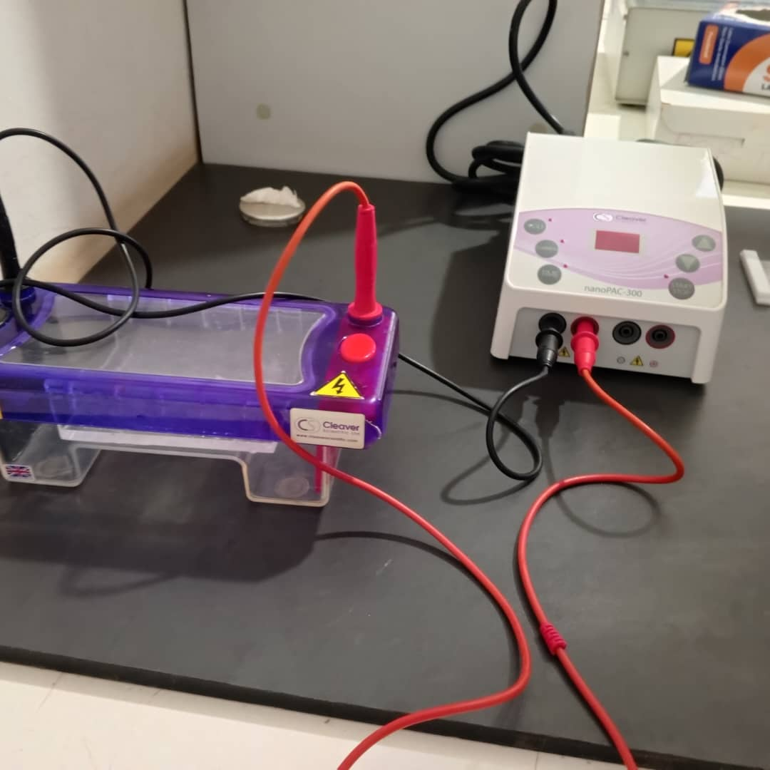

Figure 4: Pulsed Field Gel Electrophoresis System
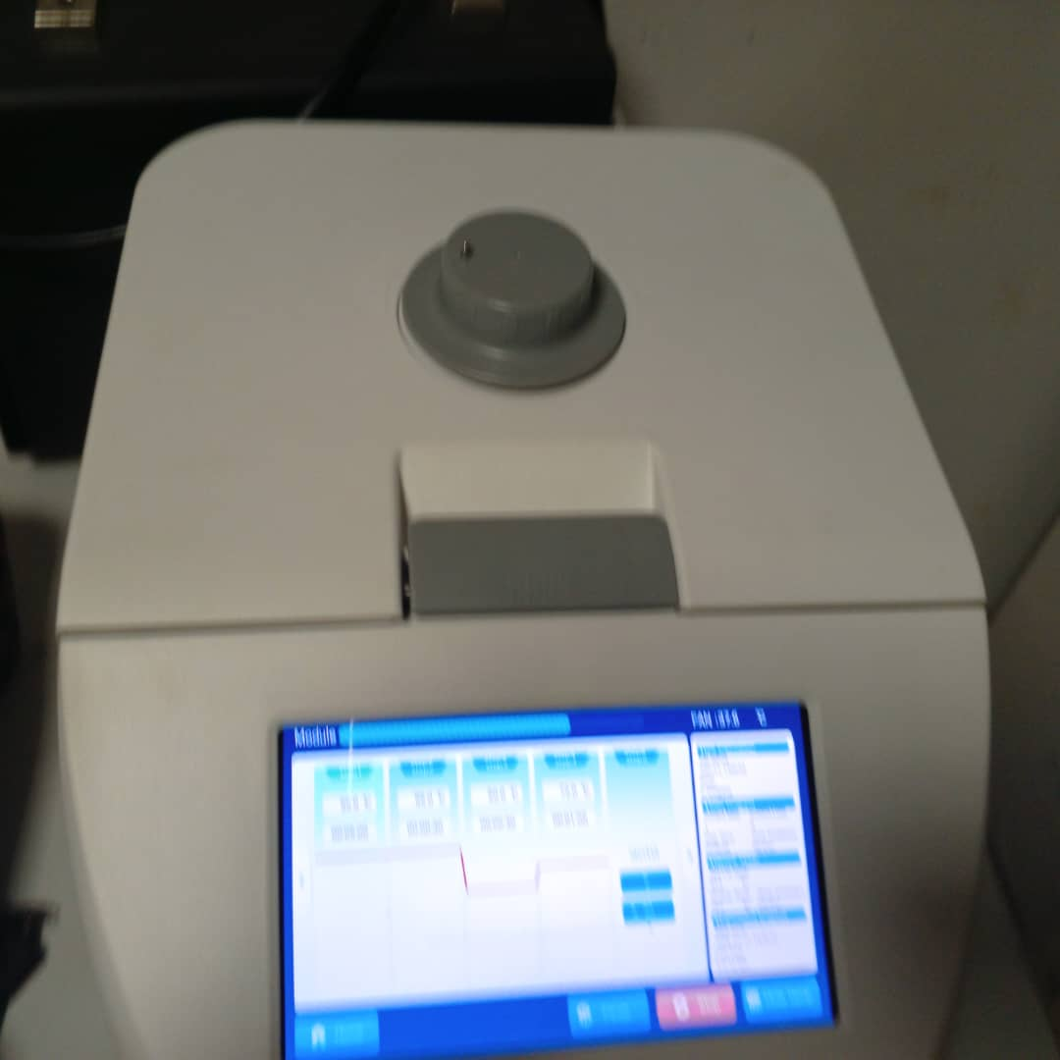

Figure 4: PCR Machine

3.3 PREPARATION OF THE MASTER MIX
Pipette the master mix solution into 0.5ml Eppendorf tube. After the master mix was prepared, 2µl of DNA templates were added to each to make the reaction mixture volume 25µl each and put into the thermocycler for amplification for 40cycles.
Below are the quantities that was used for the preparation of this work (master mix)
Reagents quantities (µl) quantities (µl) X8
Water 17.375 139
Buffer 5 40
Denitrification 0.5 4
Forward primer 0.5 4
Reverse primer 0.5 4
DNA polymerase 0.5 1
DNA 2
$\frac{192}{2}=24µl$

3.4 PCR AMPLIFICATION FOR NUCLER
The samples were inherited. A total of Nineteen (19) samples were taken through the Polymerase Chain Reaction process. The key components of the PCR reaction include several crucial constituents such as; Taq. Polymerase (Polymerase obtained from Thermus aquaticus), primers (forward and reverse), template DNA, Deoxynucleotide triphosphates (dNTPs), and PCR buffer. The primers used for the amplification of the 18SrRNA are as follows;
Forward Primer (Acanth_18SrRNA_F_FA); 5´- AGATTAAGCCATGCATGCGTAAG -3´
Reverse Primer (Acanth_ 18SrRNA_ R_ FA); 5´- TGATCCTTCTGCAGGTTCACCTAC-3´
(Verweyen et al., 2011)
and the primers used for the amplification of the Internal Transcribed Spacer (ITS) are as follows;
Forward Primer (Acanth_ITS_F_FA); 5´- GTCGTAACAAGGTTTCCGTA -3´
Reverse Primer (Acanth_ITS_R_FA); 5´- TATGCTTAAATTCAGCGGGT -3´
(Da Graça et al., 2018)

CONDITIONS FOR 18SrRNA
The PCR was cycled as follows;

95˚c
95˚c
72 ˚c
72 ˚c

00:30
05:00
4 ˚c
55˚c

07:00
00:30
00:30
͚

CONDITIONS FOR ITS
The PCR was cycled as follows;
95˚c
95˚c
72 ˚c
72 ˚c

00:30
05:00
1min: 30sec
4 ˚c
50˚c

07:00
00:30
͚

The PCR was cycled as follows; Denaturation is the first stage of the PCR. The template was subjected to initial and final temperature of 94°C for 5 mins and 30 sec for both 18SrRNA and ITS respectively. During the annealing stage, the reaction was cooled to 55°C for 30 sec for the 18SrRNA and 50°C for 30 sec for the ITS. This occurred for 40 cycles. Extension, the final step; the block temperature is increased to 72°C for 1 min: 30 sec and 7 mins for both the 18SrRNA and ITS and then stored at 4 ˚c at infinity respectively.

3.5 PREPARATION OF THE GEL ELECTROPHORESIS FOR MICTOCHONDRIAL
Using Agarose gel of 1.5 %, the PCR amplicons were separated and viewed. The procedure that was followed for the gel electrophoresis preparation includes:
The Agarose Powder was measure in 0.75g using electronic scale and dissolves in 50ml of 1x TBE buffer into a Duram bottle and swirl gently. Gently swirl the mixture and microwave it to uniformly dissolve the mixture for 2mins. 250µl of Ethidium Bromide was added and swirl gentle. The gal box was then corked to prevent the mixture of the buffer and the Agarose from escaping and the comb was placed inside the cast to create holes which is called walls. Before quickly casting in a gel tank and allowed it for 30mins to solidify. Making sure to set the gel apparatus even before the measurement of the agarose power. The mixture then was allowed to solidify to form a gel. 5ul of the PCR amplicons were mixed with 2ul of (6x loading dye Bromophenol blue with xylene cyanol-GENAXXON Bioscience) and the Quick Load purple 1200bp DNA molecular leader of the 18SrRNA and 700bp for the ITS were then pipetted into each well. The gel was run using a power supply at 60V for 50 mins. The gel was viewed under the Cleaver Scientific UV Transilluminator and imaging done by Gel Documentation system (Cleaver Scientific Micro-Doc) for the analysis of the samples.

CHAPTER FOUR
4.1 RESULTS
This practical was successful and a lot of observations that was made which we figured out that
the bands appeared clearly on the agarose gal indicating it is Acanthocephala. The PCR analysis yielded significant findings regarding the effectiveness of 18S rRNA and ITS primers in amplifying acanthocephala species in urban rodent samples. However, 6 bands appeared out of 10 bands for the 18S rRNA primer and 9 bands appeared out of 10 bands for the ITS primer as shown in the pictures below.
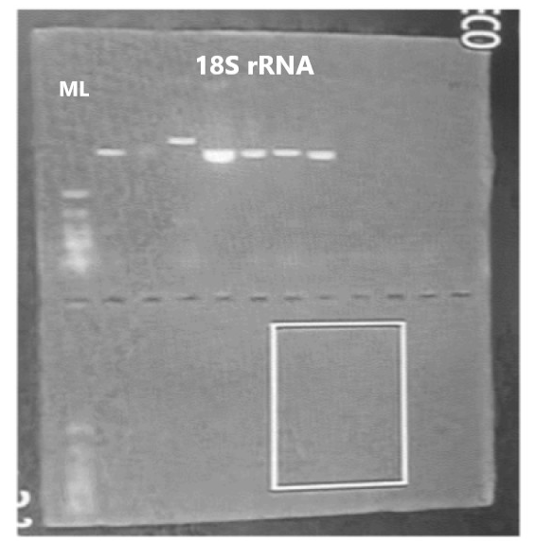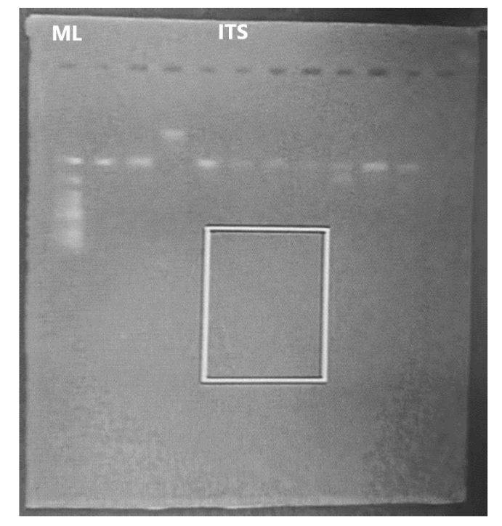
Figure 3 & 4: A picture of a gel results for Acanthocephala isolates from rats.
These results revealed that both 18S rRNA and ITS primers can be used for molecular molecular identification of acanthocephala species in urban rodents.

CHAPTER FIVE
4.2 DISCUSSION
These results have revealed the presence of Acanthocephala using nuclear markers. The application of molecular markers, particularly the nuclear 18S rRNA gene, facilitated accurate identification of Acanthocephala species, surmounting the constraints of conventional morphological identification frequently affected by intraspecific variability and overlapping morphological characteristics. It is an undisputable fact that, the exploitation of molecular techniques has for investigation, isolation and examination of accurate prevalence of Acanthocephala which consist of over 1200 species where different species and cases have been reported. Moreover, although the identification of Acanthocephala species using molecular methods to get the information like the result above need improvement, however the result has shown to be a potential useful tool in epidemiological studies because Acanthocephala can cause a parasitic zoonotic infection (infections of rodents that also affect humans) in humans which is known as Acanthocephaliasis and can also facilitate the formulation of tailored interventions and control strategies, thereby reducing the risks linked to Acanthocephala infections in urban settings. In order to evaluate zoonotic hazards and put into practice efficient public health measures, it is crucial to comprehend Acanthocephala of urban rodents.

CHAPTER SIX
CONCLUTION AND RECOMMENDATION
6.1 CONCLUTION
This experiment was successful demonstrates the effectiveness of molecular work in identifying acanthocephala species in urban rodents. The result has shown to be a potential useful tool in epidemiology studies where acanthocephala exposure is a concern in humans and also contribute to the understanding of acanthocephala species in urban localities. Despite the economic and medical importance of acanthocephala have been identified as good indicators of environmental monitoring and contamination. Only few cases of acanthocephala of humans has been identified and reported and which is mostly cause by M. moniliformis species. Since the use of molecular Markes around 1990s have proven to be one of the most useful and versatile techniques in biological science research and has help in the transformation of our lives that would have been unpredictable have shown promising results.

6.2 RECOMMENDATION
This study recommends that further research should be conducted to explore the prevalence, distribution and transmission of acanthocephala infection in urban localities and more molecular techniques and knowledge should be apply in the identification of acanthocephala species in urban rodents. Furthermore, effective strategies should be developed for the management of acanthocephala infections and also the potential risk to public health.

REFRENCES
Amin, O. M. (2013). Classification of the acanthocephala. Folia Parasitologica, 60(4), 273–305. https://doi.org/10.14411/fp.2013.031
Beatriz, N., Martins, G., & Robles, R. (2017). A new species of Moniliformis from a Sigmodontinae rodent in Patagonia ( Argentina ). https://doi.org/10.1007/s00436-017-5508-9
Berenji, F., Fata, A., & Hosseininejad, Z. (2007). A case of Moniliformis moniliformis (Acanthocephala) infection in Iran. The Korean Journal of Parasitology, 45(2), 145–148. https://doi.org/10.3347/kjp.2007.45.2.145
Da Graça, R. J., Fabrin, T. M. C., Gasques, L. S., Prioli, S. M. A. P., Balbuena, J. A., Prioli, A. J., & Takemoto, R. M. (2018). Topological congruence between phylogenies of Anacanthorus spp. (Monogenea: Dactylogyridae) and their Characiformes (Actinopterygii) hosts: A case of host-parasite cospeciation. PLoS ONE, 13(3), 1–14. https://doi.org/10.1371/journal.pone.0193408
Dahmana, H., Granjon, L., Diagne, C., Davoust, B., Fenollar, F., & Mediannikov, O. (2020). Rodents as hosts of pathogens and related zoonotic disease risk. Pathogens, 9(3). https://doi.org/10.3390/pathogens9030202
Dini, F. M., Tondi, C. M., & Galuppi, R. (2024). Helminthofauna Diversity in Synanthropic Rodents of the Emilia-Romagna Region ( Italy ): Implications for Public Health and Rodent Control.
García-Varela, M., Cummings, M. P., De León, G. P. P., Gardner, S. L., & Laclette, J. P. (2002). Phylogenetic analysis based on 18s ribosomal RNA gene sequences supports the existence of class polyacanthocephala (acanthocephala). Molecular Phylogenetics and Evolution, 23(2), 288–292. https://doi.org/10.1016/S1055-7903(02)00020-9
Gazi, M., National, C., Kim, J., Universitaria, C., Park, C., Museum, N. H., Road, C., & Park, J. (2016). Zoologica Scripta Mitogenomic phylogeny of Acanthocephala reveals novel Class relationships. November 2015, 437–454. https://doi.org/10.1111/zsc.12160
Gomes, A. P. N., Costa, N. A., Gentile, R., & Vilela, R. V. (2020). Morphological and genetic description of Moniliformis necromysi sp . n . ( Archiacanthocephala ) from the wild rodent Necromys lasiurus ( Cricetidae : Sigmondontinae ) in Brazil.
Haustein, T., Lawes, M., Harris, E., & Chiodini, P. L. (2010). An eye-catching acanthocephalan. Clinical Microbiology and Infection, 16(6), 787–788. https://doi.org/10.1111/j.1469-0691.2009.02896.x
Heckmann, R. A., Dallarés, S., Constenla, M., & Kuzmina, T. (2021). New morphological and molecular perspectives about Macracanthorhynchus hirudinaceus ( Acanthocephala : Oligacanthorhynchidae ) from wild boar , Sus scrofa Linn ., in Ukraine.
Jeronimo, É., Lidiany, G., Cavalcanti, D., & Massato, R. (2021). Acanthocephalans parasites in farmed fish in Brazil : A review. July, 1–10. https://doi.org/10.1111/are.15522
Lotfy, W. (2020). Neglected rare human parasitic infections: Part III: Acanthocephaliasis. Parasitologists United Journal, 13(3), 145–150. https://doi.org/10.21608/puj.2020.47335.1090
Lotfy, W. M. (2020). Neglected rare human Acanthocephaliasis Wael M Lotfy parasitic infections : Part III : https://doi.org/10.21608/PUJ.2020.47335.1090
Mathison, B. A., Bishop, H. S., Sanborn, C. R., Dos Santos Souza, S., & Bradbury, R. (2016). Macracanthorhynchus ingens Infection in an 18-Month-Old Child in Florida: A Case Report and Review of Acanthocephaliasis in Humans. Clinical Infectious Diseases, 63(10), 1357–1359. https://doi.org/10.1093/cid/ciw543
Mathison, B. A., Mehta, N., & Couturier, M. R. (2021). Human Acanthocephaliasis: a Thorn in the Side of Parasite Diagnostics. Journal of Clinical Microbiology, 59(11), 1–8. https://doi.org/10.1128/JCM.02691-20
McDonough, K., Johnson, T., Goebel, T., Reinhard, K., & Coe, M. (2023). Paleoparasitology of Human Acanthocephalan Infection: a Review and New Case From Bonneville Estates Rockshelter, Nevada, U.S.a. The Journal of Parasitology, 109(2), 65–75. https://doi.org/10.1645/22-92
Meerburg, B. G., Singleton, G. R., & Kijlstra, A. (2009). Rodent-borne diseases and their risks for public health (Vol. 35, Issue November 2008). https://doi.org/10.1080/10408410902989837
Muhammad, N., Ma, J., Sayed, M., Wu, S., & Zhu, X. (2019). Infection , Genetics and Evolution Characterization of the complete mitochondrial genome of Centrorhynchus milvus Ward , 1956 ( Acanthocephala : Polymorphida ) and its phylogenetic implications. 75(April), 3–8. https://doi.org/10.1016/j.meegid.2019.103946
Near, T. J. (2002). Acanthocephalan phylogeny and the evolution of parasitism. Integrative and Comparative Biology, 42(3), 668–677. https://doi.org/10.1093/icb/42.3.668
Perrot-Minnot, M. J., Cozzarolo, C. S., Amin, O., Barčák, D., Bauer, A., Filipović Marijić, V., García-Varela, M., Servando Hernández-Orts, J., Yen Le, T. T., Nachev, M., Orosová, M., Rigaud, T., Šariri, S., Wattier, R., Reyda, F., & Sures, B. (2023). Hooking the scientific community on thorny-headed worms: Interesting and exciting facts, knowledge gaps and perspectives for research directions on Acanthocephala. Parasite, 30. https://doi.org/10.1051/parasite/2023026
Press, A. (1971). Acanthocephalan Infections of Man , with Two New Records Author ( s ): Gerald D . Schmidt Published by : Allen Press on behalf of The American Society of Parasitologists Stable URL : https://www.jstor.org/stable/3277920 REFERENCES Linked references are av. 57(3), 582–584.
Ramos, C. A., Maria, S., & Porto, D. A. (2020). Occurrence , pathogenicity , and control of acanthocephalosis caused by Neoechinorhynchus buttnerae : A review. 2961(131637), 1–7.
Seifollahi, Z., Sarkari, B., Motazedian, M. H., Asgari, Q., Ranjbar, M. J., & Abdolahi Khabisi, S. (2016). Protozoan Parasites of Rodents and Their Zoonotic Significance in Boyer-Ahmad District, Southwestern Iran. Veterinary Medicine International, 2016. https://doi.org/10.1155/2016/3263868
Seixas, A. T. De. (2020). Challenges in the control of acanthocephalosis in aquaculture : special emphasis on Neoechinorhynchus buttnerae. 1360–1372. https://doi.org/10.1111/raq.12386
Verweyen, L., Klimpel, S., & Palm, H. W. (2011). Molecular phylogeny of the acanthocephala (class palaeacanthocephala) with a paraphyletic assemblage of the orders polymorphida and echinorhynchida. PLoS ONE, 6(12). https://doi.org/10.1371/journal.pone.0028285

Near, T. J. (2002). Acanthocephalan phylogeny and the evolution of parasitism. Integrative and Comparative Biology, 42(3), 668-677.
Garcıa-Varela, M., Cummings, M. P., de León, G. P. P., Gardner, S. L., & Laclette, J. P. (2002). Phylogenetic analysis based on 18S ribosomal RNA gene sequences supports the existence of class Polyacanthocephala (Acanthocephala). Molecular Phylogenetics and Evolution, 23(2), 288-292.
da Graca, R. J., Fabrin, T. M., Gasques, L. S., Prioli, S. M., Balbuena, J. A., Prioli, A. J., & Takemoto, R. M. (2018). Topological congruence between phylogenies of Anacanthorus spp.(Monogenea: Dactylogyridae) and their Characiformes (Actinopterygii) hosts: A case of host-parasite cospeciation. PLoS One, 13(3), e0193408.
Verweyen, L., Klimpel, S., & Palm, H. W. (2011). Molecular phylogeny of the Acanthocephala (class Palaeacanthocephala) with a paraphyletic assemblage of the orders Polymorphida and Echinorhynchida. PLoS One, 6(12), e28285.

